Unit 1. “My Skills and achievements contribute to the society itself”
Guía n° 2 English Language

Nombre: |  |  |  | Curso: | IIIrd | Fecha
Puntaje Evaluación |  |  | Puntaje de corte (60%):
Puntaje obtenido: |  |  | Calificación:

INSTRUCCIONES:
- No se podrá entregar la guía sin estar resuelta completamente.
- La guía puede ser resuelta con apoyo de un diccionario. No está permitido copiar trabajos de otros compañeros/as.
- La guía debe ser entregada el día Jueves 6 de Abril

Objetivos: Comprensión lectora
Contenidos: Vocabulario relacionado al mundo del trabajo

I. Vocabulary
A) Look at these images related to occupations and professions.

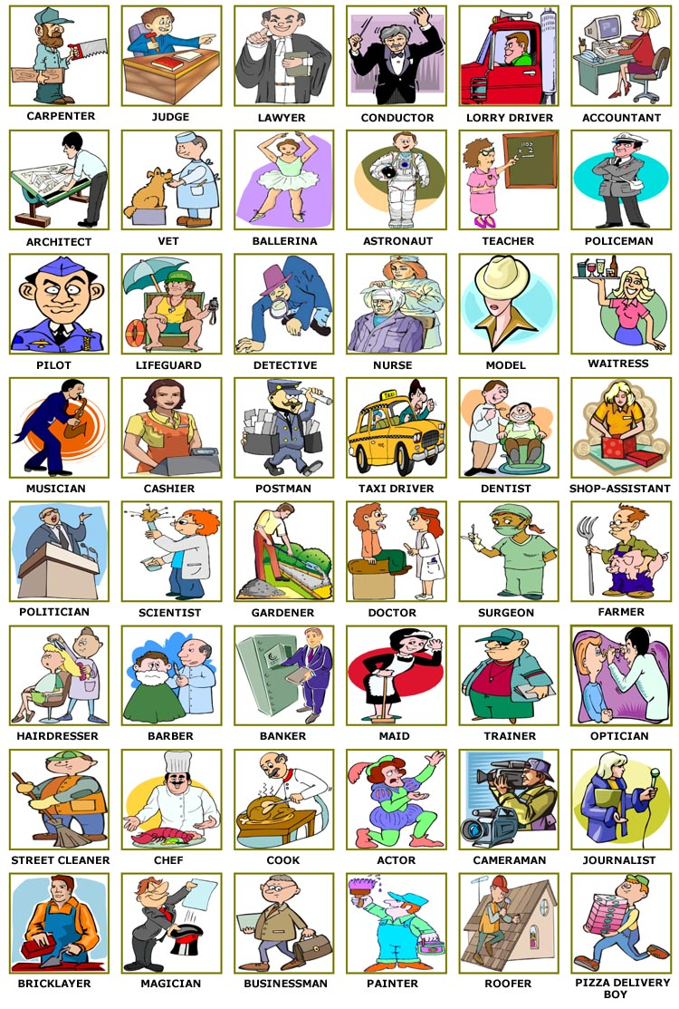
b) Look at the images and make a reflection: Is any profession or occupation of your interest?

II. Examples

a) Look at the examples about professions and occupations. Is someone you know have one of these profession or occupation?
The electrician came and changed our house wires | 
The waitress asked our order | 
When I was younger I wanted to be an astronaut | 
The surgeon is at the surgery room | 
Sandra the veterinarian is taking care of Firulais | 
The dustman labor is hard | 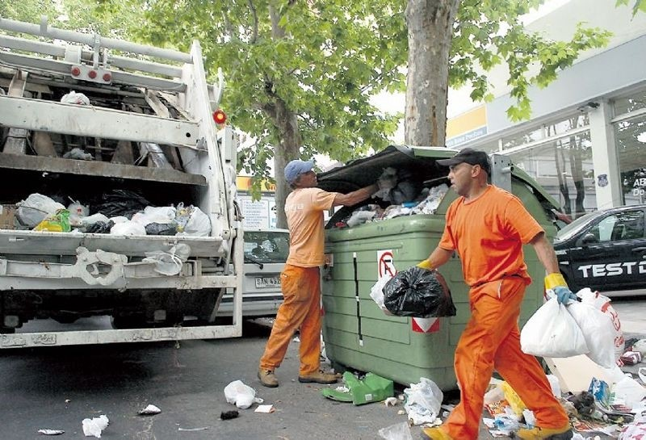
Catalina wants to be a mechanic | 
The cook created a new dish | 
The saleswoman offers 50% off on smartphones | 

Videos
Jobs and places to work
https://www.youtube.com/watch?v=PJdyjiaPSyc

III . Exercises

- Highlight the correct option

1. The person who is certified to treat our teeth is a:
a) plumber b) farmer c) dentist
2. Michael repairs cars. He is a:
a) mechanic b) paramedic c) auctioneer

3. Brad Pitt plays in movies. He is an:
a) puppeteer b) actor c) magician
4. The person who brings our mail is a:
a) post man b) journalist c) delivery boy

5. He takes pictures at different occasions. He is a:
a) director b) operator c) photographer

6. Mary dances at the opera. She is a:
a) ballerina b) dancer c) pianist

7. She makes clothes for people. She is a:
a) constructor b) tailor c) inventor

8. David Beckham is a famous sportsman. He is a:
a) referee b) DJ c) footballer

9. He works on a cargo ship. He is a:
a) sailor b) shepherd c) janitor
10. Peter mixes music in a disco. He is a:
a) manager b) DJ c) violinist

11. The person who designs buildings is an:
a) drummer b) lawyer c) architect

12. He works in a restaurant, preparing drinks. He is a:
a) waiter b) receptionist c) bartender

13. My friend writes articles for a local newspaper.
He is a: a) journalist b) writer c) inventor

14. She works in a hotel, at the front desk. She is a:
a) housewife b) waitress c) receptionist

15. He looks after sheep. He is a:
a) surgeon b) shepherd c) vet

16. She presents the weather forecast. She is a:
a) hairdresser b) model c) weather presenter

17. She operates a telephone switchboard. She is an:
a) operator b) doctor c) surgeon

18. He prepares food in a restaurant. He is a:
a) waiter b) cook c) gardener
19. He fights fires. He is a:
a) farmer b) lawyer c) fireman

20. He digs in the ground for coal and minerals. He is a:
a) driver b) miner c) plumber

21. She sells houses and land for other people.
She is a: a) realtor b) nun c) sales assistant

22. The person who is cutting down trees is a:
a) dealer b) usher c) lumberjack

23. The person who arranges women’s hair is a:
a) sculptor b) hair dresser c) housewife

b. Fill in the sentences with a job from the word bank: (1 pt)
Lawyer - Nurse - Captain -Electrician - Singer Rescuer – Judge – Doctor – Archaeologist - Magician -Teacher – Priest – Vet - Bank Manager - Director - Nun -Janitor – Auctioneer - Camera Man
Police Officer – Fisherman - Waiter - Reporter Conductor - Pilot

- The_________________ sentenced the thief to 3 years in prison.
- The_________________ found a very old vase on the site.
- The_________________ of the ship decided to lower the life boats.
- They________________ were happy that the signed for the loan.
- The_________________ filmed the debate on tape.
- The _________________ presented his case before the jury.
- When she was 25 she decided to enter a convent and become a______________ .
- After the avalanche, they called in a _______________
- They liked her voice very much, so they gave her a 5 year contract as a______________ in their club.
- I have to take my dog to the________________ .
- The_____________ caught a lot of fish today.
- We saw a _______________ at the circus doing some good tricks.
- The________________ said that I should stay in bed for a few days.
- The________________ started the betting at 10 thousand dollars.
- They________________ hired a new at the opera.
- Who is the ________________ of this movie?
- We called the__________________ to check the alarm system.
- The killer was arrested by the _____________ .
- There were________________ many at the press conference.
- When she saw the serious condition of the patient, the______________ called in the doctor.
- The ________________ said that we have to do our homework for next week.
- The ________________landed the plane safely.
- The child was baptized by a young ____________ .
- The school ________________ cleaned the classrooms.
- Our ________________ forgot to bring our order.

C. Career test

Instructions: Highlight the items you think you would enjoy in each section. Mark as many items that apply.
What does the letters mean? Each of these letters represents a personal interest category. The columns you have the most check marks in show where your interests are the strongest. Listed below are some jobs related to each interest type.
"R" Section  "I" Section  "A" Section | "S" Section  "E" Section  "C" Section
  Repair a car
  Do wood working
  Refinish furniture
  Explore a forest
  Arrest lawbreakers
  Plant a garden
  Build furniture
  Run a race
  Drive a truck
  Study causes of disease
  Do a science project
  Study human anatomy
  Study insects
  Research solutions to
  environmental problems
  Collect minerals and rocks
  Study the solar system
  Do math problems
  Talk to a scientist
  Study plants
  Sing before the public
  Design clothing
  Decorate a home or office
  Direct a play
  Write a story or play
  Design a poster
  Create a sculpture
  Arrange flowers
  Make videos
  Act in a performance
  Teach children
  Care for a sick person
  Teach a friend
  Interview clients
  Help a person overcome difficulties
  Be a hospital volunteer
  Help a charity
  Make people laugh
  Baby-sit
  Sell cars
  Make a speech
  Be the boss of other workers
  Start a club
  Save money
  Sell things
  Lead a meeting
  Take charge of a project
  Sell magazines door to door
  Keep detailed records
  Operate business machines
  Organize a work area
  Take telephone messages
  Attend to details
  Balance a budget
  Use a word processor
  Proofread a document
  Create a filing system
Now, go back to the sections. Add up how many boxes you checked in each section and fill in the totals for each in the space provided below.
R ______  I ______  A ______ | S ______  E ______  C ______

What the letters mean
Each of these letters represents a personal interest category. The columns you have the most check marks in show where your interests are the strongest. Listed below are some jobs related to each interest type.
Realistic Careers: Mechanic, fire fighter, police officer, forester, chef, carpenter, landscape architect, military, athletic trainer, engineer.
Investigative Careers: Biologist, psychologist, computer programmer, doctor, engineer, pharmacist, mathematician, dietician.
Artistic Careers: Artist, musician, novelist, photographer, lawyer, interior designer, television announcer, actor, disc jockey, art teacher, reporter, architect.
Social Careers: Social worker, counselor, teacher, nurse, minister, school administrator, occupational therapist.
Enterprising Careers: Business owner, manager, sales person, travel agent, public relations, personnel director, real estate agent, florist.
Conventional Careers: Accountant, secretary, banker, bookkeeper, math teacher, treasurer, surgical technologist, dental assistant.

IV. Extra:
Jobs and occupations game
https://www.englishexercises.org/makeagame/viewgame.asp?id=4574&ads=no

Send this guide to:
Miss. Francisca Ipinza III°C francisca.ipinza@elar.cl
Miss. Daniela Moreno III°A – III°B daniela.moreno@elar.cl

